Multiple choice section

|  |  |  |  |  |  |  |  |  |  |  |  |
| --- | --- | --- | --- | --- | --- | --- | --- | --- | --- | --- | --- |
| Question | 1 | 2 | 3 | 4 | 5 | 6 | 7 | 8 | 9 | 10 | 11 |
| Answer | D | A | A | C | D | A | B | C | A | A | D |

Question 1 [9.2]

D

Put the data in order.

5 5 6 8 9

The median is the value in the middle: 6

Question 2 [9.3]

A

Pies 25%

Bombers 30%

Total 55%

Question 3 [9.7]

A

4 is the only successful outcome.

Question 4 [9.4]

C

A histogram is the best because grouped measurements are involved.

Question 5 [9.2]

D

Add up the values and divide by 7.

 = 8

Question 6 [9.1]

A

44 43 45 45

There are four results.

Question 7 [9.7]

B

Pr(Victor wins) =  × 100% ≈ 39%

Question 8 [9.4]

C

32% of 360° = ≈ 115°

Question 9 [9.5]

A

You can be certain it rained only when the water level rises.

This occurred in Weeks 1, 5 and 8.

Question 10 [9.4]

A

Electricity is the first section (36%).

Waste is the top section (3%).

This gives a total of 39%.

Question 11 [9.2]

D

0, 1, 1, 2, 2, 4, 6, 6, 8, 8, 8, 8, 9, 9, 12, 15

There are more 8s than any other number.

Multiple-choice total marks: 11

Short answer section

Question 12 3 marks [9.1]

(a) The *mode* of a data set is the result that appears most often.

(b) Numerical data that has a defined number of possible outcomes is called *discrete data*.

(c) If you divide the number of successful outcomes by the total number of outcomes you are finding the *probability* of an event.

Question 13 2 marks [9.1]

Both frequency tables and stem-and-leaf plots are ways of grouping data. The biggest difference is that a frequency table will only tell you how many results are in each group, whereas a stem-and-leaf plot maintains the individual data scores. For this reason, a stem-and-leaf plot is often a better choice; however, it takes a little longer to prepare because you need to order the data.

Question 14 10 marks [9.3]

(a) (i) Mean:  
 =  ≈ 4.8

(ii) Median = 5 since both middle numbers are 5

(iii) Mode = 7

(iv) Range = 7 – 2 = 5

(b) (i) Mean =  ≈ 5.1. The mean has increased by 0.3  
(ii) The median remains the same.  
(iii) There are now three numbers with frequency of three so there is no distinct mode.  
(iv) Range = 12 – 2 = 10. The range has increased by 5.

Question 15 4 marks [9.5]

(a) Joanie spent $40 at 11 am.

(b) Joanie withdrew $100 at noon.

(c) Joanie had $80 in her wallet from 9.30 am until 11 pm: 1 hours.

(d) Joanie had more than $90 in her wallet from 9.30 am until noon: 2 hours.

Question 16 4 marks [9.3]

(a)

|  |  |
| --- | --- |
| STEM | LEAF |
| 0 | 5 6 8 9 |
| 1 | 0 1 2 4 5 9 9 |
| 2 | 0 2 5 5 6 6 7 |
| 3 | 1 7 8 |
| 4 | 0 3 4 |

(b) Median =  = 12  
Range = 43 – 0 = 43  
On average students in the class did more than an hour of homework on 12 occasions. The spread of data is very large with a difference of 43 between the highest and lowest number of occasions. There is a high proportion of students who did more than an hour of homework on less than 10 occasions.

Question 17 4 marks [9.4]

(a)  × 360° ≈ 99°

(b) 1 cm ↔ 100000  
12.76 cm ↔ 1276000  
Make the total length 12.76 cm i.e. about 128 mm.  
1 mm ↔ 10000  
962000 ÷ 10000 = 92.3 ≈ 92 mm

Question 18 5 marks [9.6]

NY is, on average, warmer than Paris in summer and colder in winter – so generally more extreme. NY’s median average monthly temperature is 17 °C with a range of 26 °C. Paris’s median average monthly temperature is 16 °C (cooler by just 1 °C) with a range of 17 °C (much less variation).

Question 19 7 marks [9.7]

(a) Pr(3) = 

(b) Pr(4, 8, 12, 16, 20) = 

(c) Pr(7, 14) = 

(d) Pr(2, 3, 5, 7, 11, 13, 17, 19) = 

(e) Pr(5, 10, 15, 20) = 

Short answer total: 39

Extended answer section

Question 20 7 marks [9.1, 9.3, 9.4]

(a) The data is continuous.

(b)

|  |  |  |
| --- | --- | --- |
| Class interval | Tally marks | Frequency |
| 11.5−<12.0 | ⏐⏐ | 2 |
| 12.0−<12.5 | ⏐⏐⏐ | 3 |
| 12.5−<13.0 | ~~⏐⏐⏐⏐~~ | 5 |
| 13.0−<13.5 | ~~⏐⏐⏐⏐~~ ⏐ | 6 |
| 13.5−<14.0 | ⏐⏐⏐ | 3 |
| 14.0−<14.5 | ~~⏐⏐⏐⏐~~ ⏐ | 6 |
|  |  | **25** |

(c)

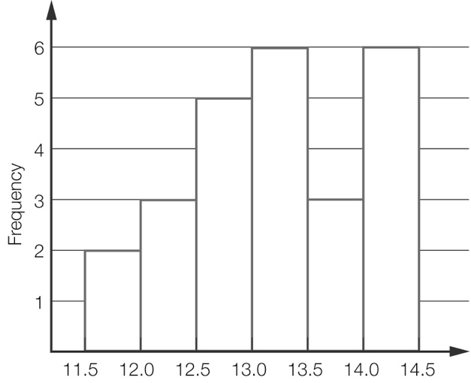

(d) Better than 13.0 seconds:  
 =  =  = 40%

Question 21 6 marks [9.2, 9.6]

For comparison, a summary of the historical data is:

|  |  |  |  |
| --- | --- | --- | --- |
| Total | Median | Highest | Lowest |
| 1215 | 99.5 | 132 | 68 |

Answers will vary – the actual values are given below.

|  |  |  |  |  |  |  |  |  |  |  |  |
| --- | --- | --- | --- | --- | --- | --- | --- | --- | --- | --- | --- |
| J | F | M | A | M | J | J | A | S | O | N | D |
| 96 | 137 | 109 | 137 | 118 | 118 | 81 | 92 | 69 | 82 | 105 | 79 |

The historical data shows slightly higher total rainfall and yet identical values for the median months. With slightly less variation from one month to another. There has been very little change.

Question 22 8 marks [9.6, 9.7]

(a) 6 + 9 + 5 + 3 + 1 = 24  
Could make the graph 12 cm i.e. 120 mm high. (Other answers possible.)

(b) 1 cm ↔ 2  
4.5 cm ↔ 9  
‘Dog’ would be 4.5 cm i.e. 45 mm high.

(c) Pr(cat) =  = 

(d) 7 + 10 + 5 + 2 + 4 = 28  
 × 12 cm ≈ 1.7 cm = 17 mm

(e) Whichever has the higher proportion will have the greater height since the total heights are the same.  
7A:  =    
7B:  =    
‘Cat’ would be the same height in both graphs.

Question 23 9 marks [9.7]

(a)

|  |  |  |  |  |  |  |
| --- | --- | --- | --- | --- | --- | --- |
|  | 1 | 2 | 3 | 4 | 5 | 6 |
| **R1** | (R1, 1) | (R1, 2) | (R1, 3) | (R1, 4) | (R1, 5) | (R1, 6) |
| **R2** | (R2, 1) | (R2, 2) | (R2, 3) | (R2, 4) | (R2, 5) | (R2, 6) |
| **G1** | (G1, 1) | (G1, 2) | (G1, 3) | (G1, 4) | (G1, 5) | (G1, 6) |
| **G2** | (G2, 1) | (G2, 2) | (G2, 3) | (G2, 4) | (G2, 5) | (G2, 6) |
| **B** | (B, 1) | (B, 2) | (B, 3) | (B, 4) | (B, 5) | (B, 6) |

(b) Pr(R, even) = 

(c) Pr(G, even) = 

(d) The game is fair because Terry has the same chance of winning that Steve has.

(e) Students will provide their own answer, but a sample game would be: Steve wins if green and odd and Terry wins if red and even.

Extended answer total: 30

TOTAL test marks: 80